Child Performance Licensing Guidance

The primary legislation and regulations for Child Performance Licensing in Great Britain are the Children and Young Persons Act 1933, the Children and Young Persons Act 1963, the Children (Performances and Activities) (England) Regulations 2014, The Children (Performances and Activities) (Scotland) Regulations 2014 and Children (Performances and Activities) (Wales) Regulations 2015.

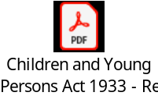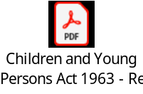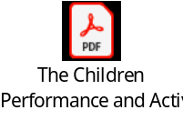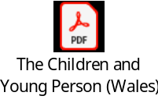

Child performance licensing and activities legislation sets out the arrangements that must be made to safeguard children when they take part in certain types of performances, whether unpaid or paid.

This includes all children from birth, until they are no longer of compulsory school age. Compulsory school age in England ends on the 30th of June in the year in which the child turns 16. In Scotland compulsory school age varies dependent on the child's birthday. Children with March-September birthdays can leave school after 31st May in their 16th year. Children with October-February birthdays can leave school at the start of the Christmas holidays in their 16th year. In Wales compulsory school age ends on the 30th of June in the year in which the child turns 16.

Each Local Authority has their own process for issuing performance licences, therefore it is important to contact the Local Authority, in which the child lives, to find out what process needs to be followed to apply for a performance licence.

For further advice and guidance, the National Network of Child Employment and Entertainment (NNCEE) is an excellent resource – https://www.nncee.org.uk

The most recent NNCEE guidance was updated in 2024:



